**Assignment-3**

**1) Write a shell script to print your name.**

**Code)**

echo -n "Enter your name: "

read name

echo "Hello! The name you've entered is $name."

**Output)**

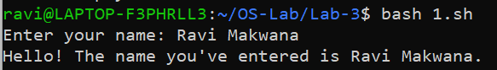

**2) Write a shell script whether a number is even or odd.**

**Code)**

echo -n "Enter number: "

read n

if [ $(($n % 2)) == 0 ]

then

echo "Even"

else

echo "Odd"

fi

**Output)**

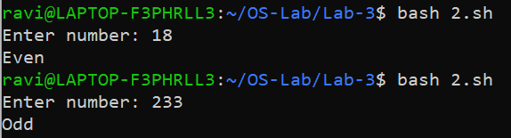

**3) Write a shell script to print a table of a given number.**

**Code)**

echo -n "Enter a number: "

read n

i=1

while [ $i -le 10 ]

do

p=$(($i*$n))

echo "$i * $n = $p"

i=$(($i+1))

done

**Output)**

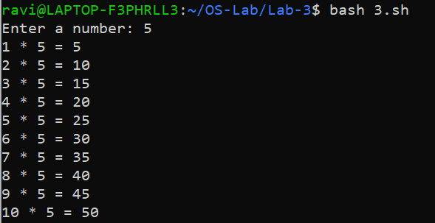

**4) Check whether a given number is prime or not.**

**Code)**

echo -n "Enter a number: "

read n

for ((i=2; i<=n/2; i++))

do

if [ $((n%i)) == 0 ]

then

echo "$n is NOT a prime."

exit

fi

done

echo "$n is a prime."

**Output)**

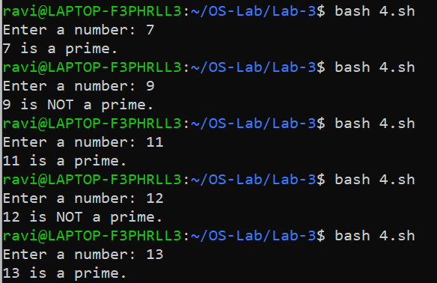

**5) Find simple interest.**

**Code)**

echo -n "Enter principle amount: "

read p

echo -n "Enter rate: "

read ra

echo -n "Enter time: "

read t

si=$(echo "scale=2; (($p*$ra*$t / 100))" | bc)

echo "Simple Interest is: $si"

**Output)**

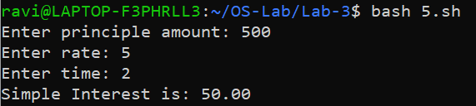

**6) Find sum of n number.**

**Code)**

echo -n "Enter no. of terms: "

read n

sum=0

for ((i=1; i<=n; i++))

do

echo -n "Enter number-$i: "

read num

sum=$(($sum+num))

done

echo "Sum is: $sum"

**Output)**

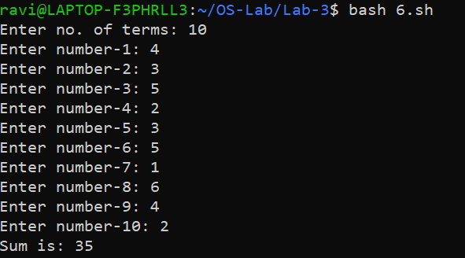

**7) Largest number of 3 numbers.**

**Code)**

echo -n "Enter 1st number: "

read a

echo -n "Enter 2nd number: "

read b

echo -n "Enter 3rd number: "

read c

if [ $a -gt $b ]

then

if [ $a -gt $c ]

then

echo "Largest is: $a"

else

echo "Largest is: $c"

fi

else

if [ $b -gt $c ]

then

echo "Largest is: $b"

else

echo "Largest is: $c"

fi

fi

**Output)**

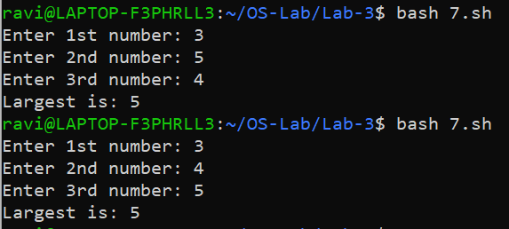

**8) Given year is leap year or not.**

**Code)**

echo -n "Enter year: "

read year

if [ `expr $year % 400` -eq 0 ]

then

echo "leap year"

elif [ `expr $year % 100` -eq 0 ]

then

echo "not a leap year"

elif [ `expr $year % 4` -eq 0 ]

then

echo "leap year"

else

echo "not a leap year "

fi

**Output)**

